**DAILY ONLINE ACTIVITIES SUMMARY**

|  |  |  |  |  |  |  |  |  |
| --- | --- | --- | --- | --- | --- | --- | --- | --- |
| **Date:** | **03/06/2020** | | | | | **Name:** | **VIRESH** | |
| **Sem & Sec** | **4th SEM & ‘B’ SEC.** | | | | | **USN:** | **4AL18CS097** | |
| **Online Test Summary** | | | | | | | | |
| **Subject** | | **Object Oriented Concepts** | | | | | | |
| **Max. Marks** | | **30** | | **Score** | | | **15** | |
| **Certification Course Summary** | | | | | | | | |
| **Course** | **Cloud Foundations** | | | | | | | |
| **Certificate Provider** | | | **Greatlearning Academy** | | **Duration** | | | **4.5 Hrs.** |
| **Coding Challenges** | | | | | | | | |
| **Problem Statement 1:** Write a Java program to find Last Digit of a^b (a to the power b) for Large Numbers.  **Problem Statement 2:** Write a code segment in java to swap two numbers using call by object reference. | | | | | | | | |
| **Status: Done** | | | | | | | | |
| **Uploaded the report in Github** | | | | | **Yes** | | | |
| **If yes Repository name** | | | | | **Lockdown-Coding**  <https://github.com/viresh-kulal/Lockdown-Coding> | | | |
| **Uploaded the report in slack** | | | | | **Yes** | | | |

**Online Test Summary: 18CS45 test was scheduled from 9:30 am to 10:00am .The portion for the IA was 2 nd and 3 rd module there were 30 questions and the time assigned was 45 minutes the questions were to predict the output of the given program.**

**The snapshot of the completion of the test and the marks allotted is attached below.**

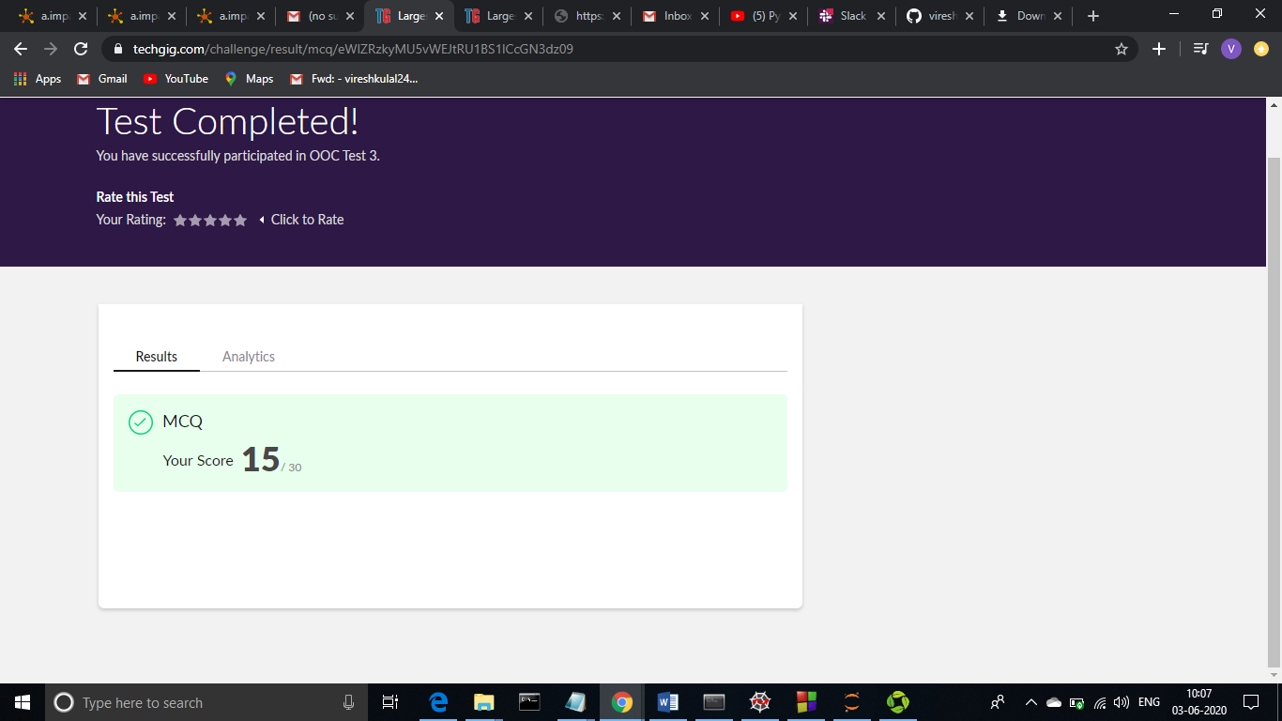

**Online Certification Course Summary:** **In today’s session I have learnt about Price Economics, Data Velocity and Distributed Computing and also about Apps for cloud and security model**

**The snapshots of today’s session is attached below.**

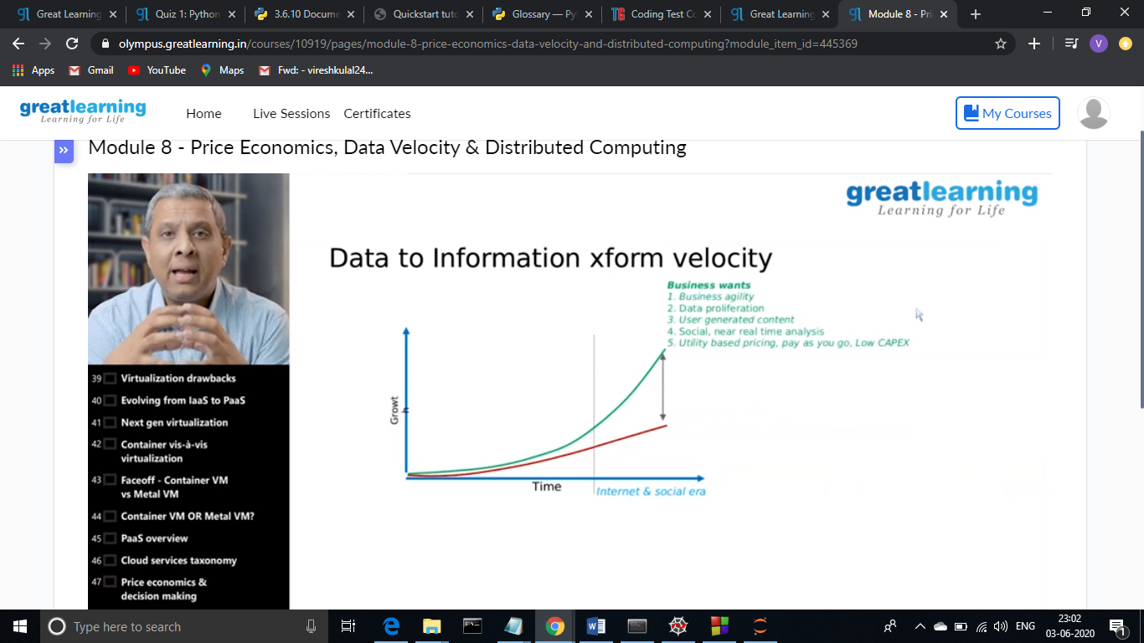 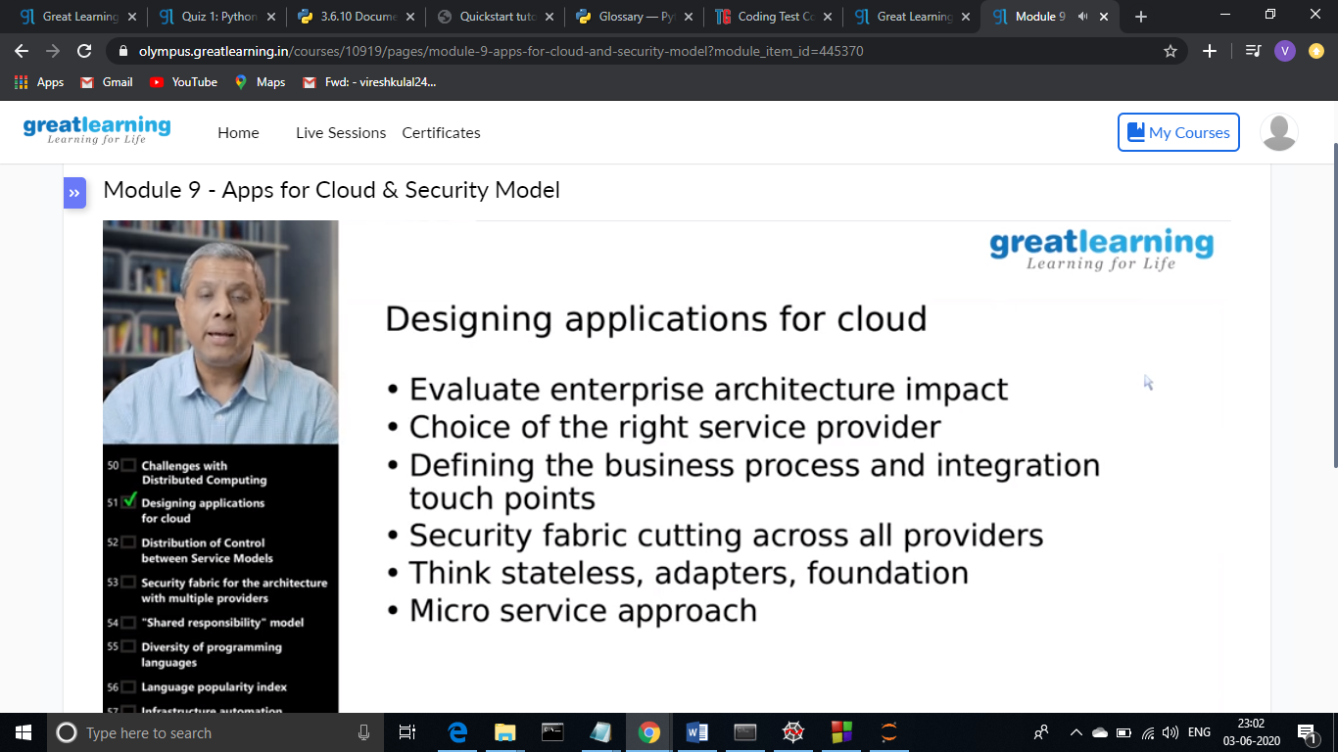

**Online Coding Summary: Today I had received one program from prof. Shilpa CSE Dept. the other from Prof. Reena Lobo CSE Dept. and Prof. Vasudev CSE Dept. The program is mentioned above (pg.01). I have also uploaded it to my Github repository.**

The Repository link is: <https://github.com/viresh-kulal/Lockdown-Coding>

The snapshots of my Github repository were I have uploaded the code. File names are C.java, Lastdigit.java and Largestswap.cpp which are shown below.

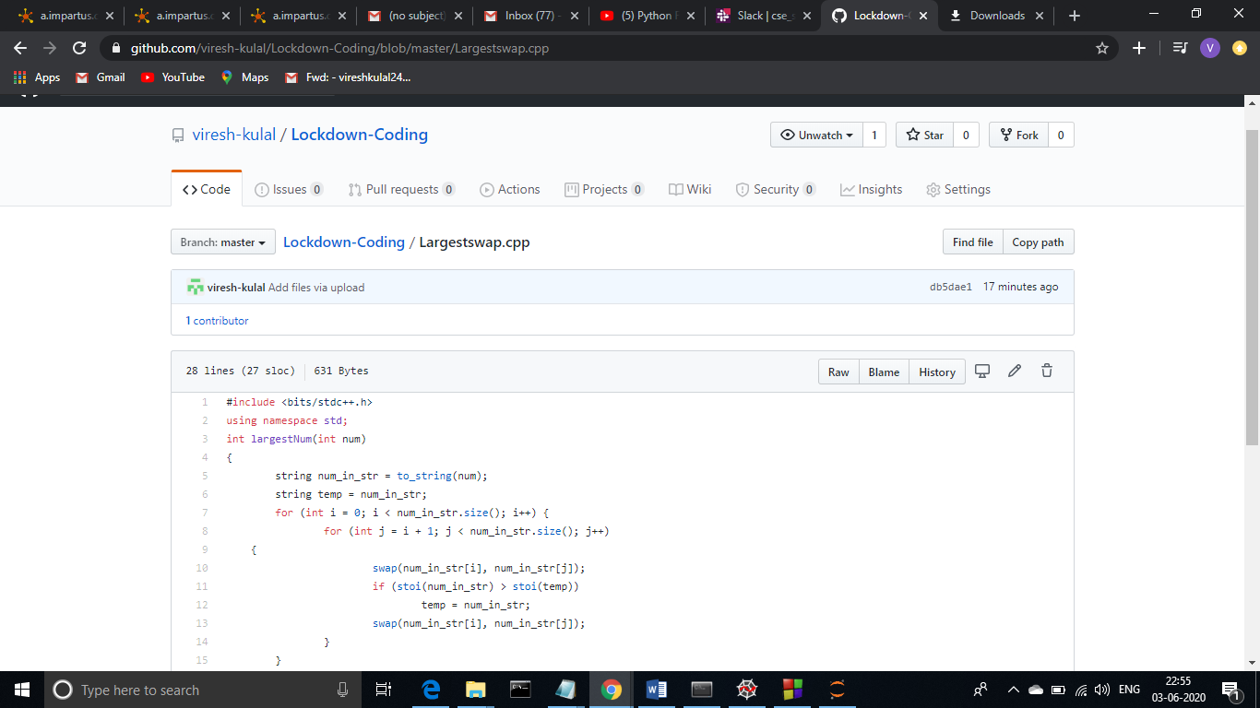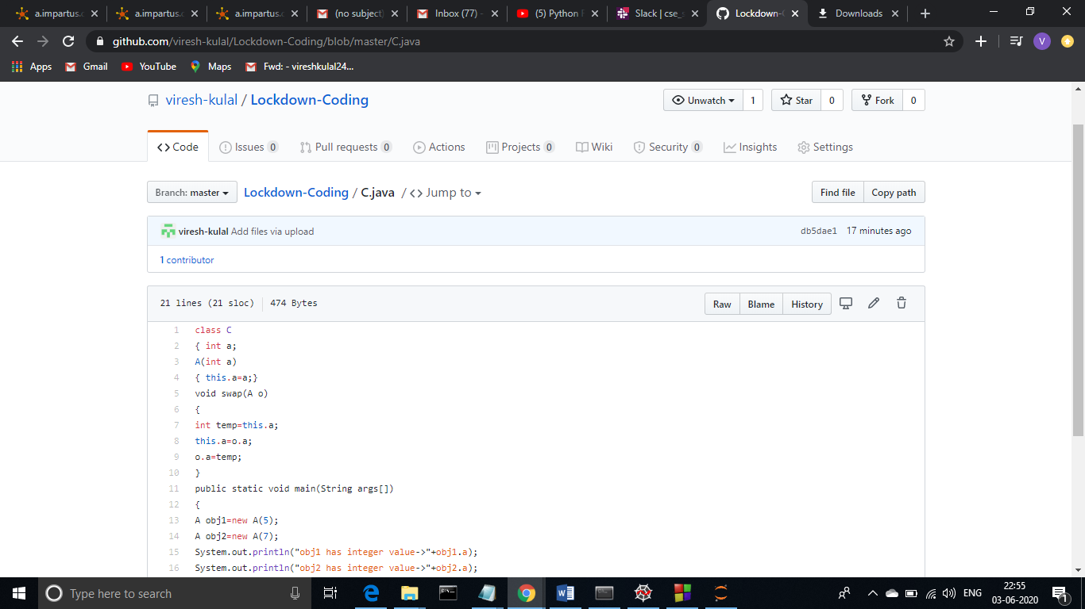

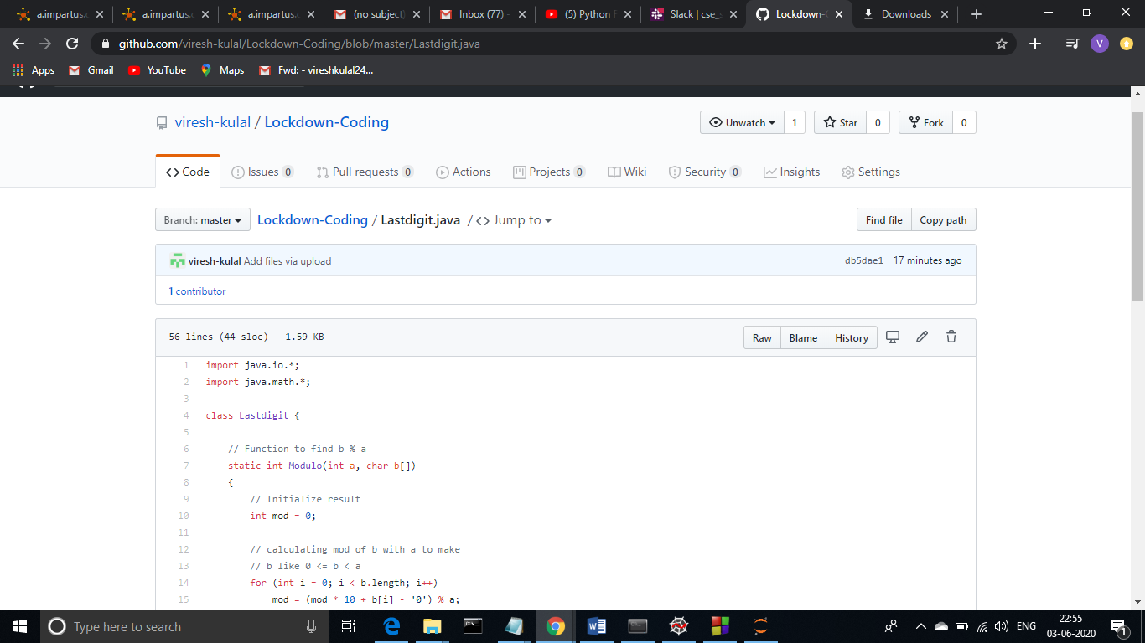

**Thank you.**